1.Configure CloudWatch logs: Configure CloudWatch logs to capture logs from your AWS resources, such as EC2 instances and Lambda functions.

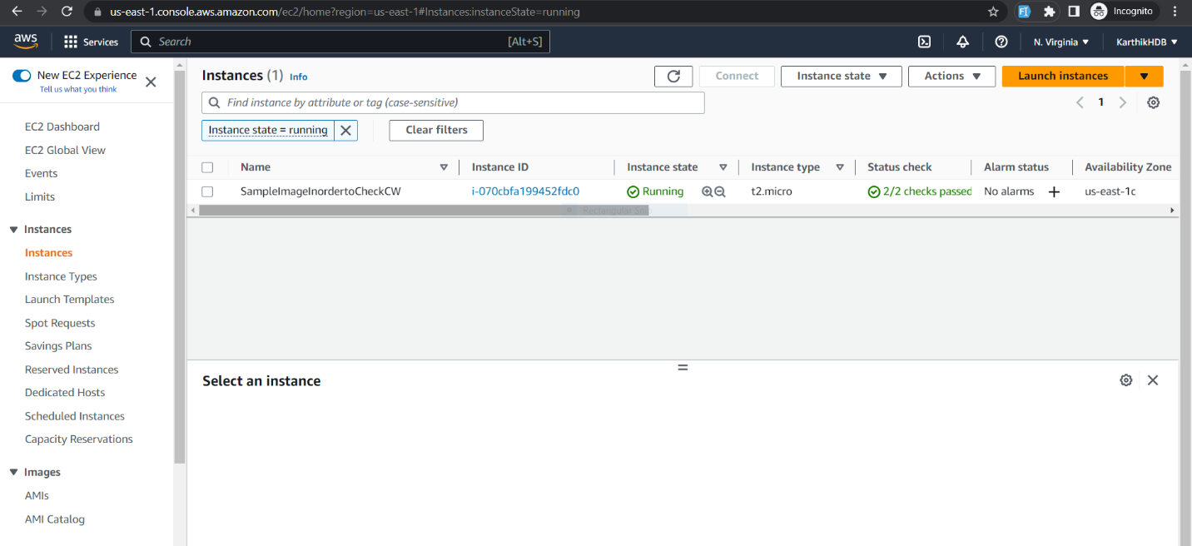

Connect it through ssh and run the following commands to install cloudwatch log agent

sudo yum update -y

sudo yum install -y awslogs //to install awslogs agent

sudo systemctl start awslogsd (to start awslogs)

You will see the logs in the cloudwatch logs in aws management console like below

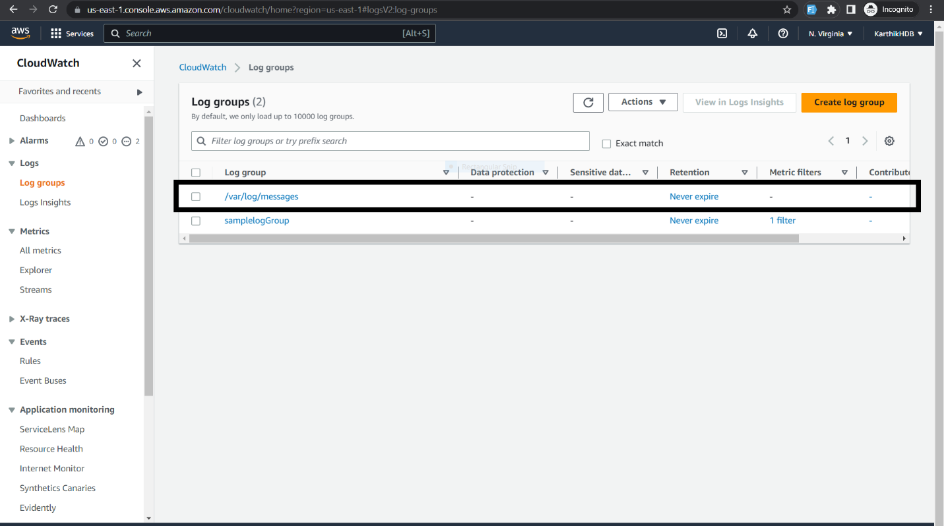

2.Monitor billing and cost with CloudWatch: Use CloudWatch to monitor your AWS billing and cost, and create alerts when certain thresholds are reached.

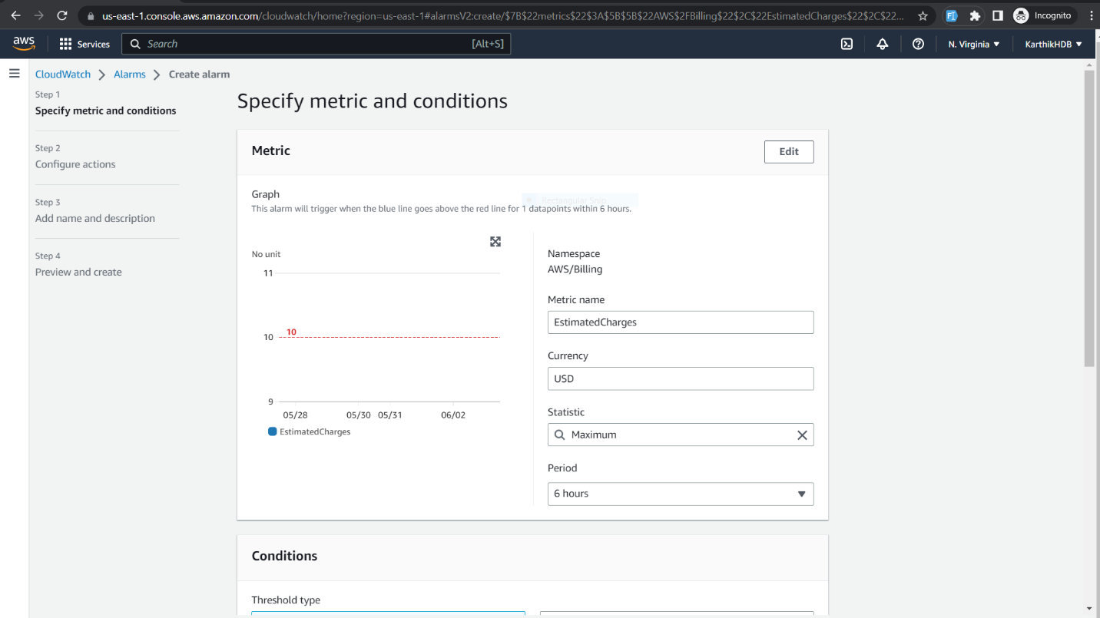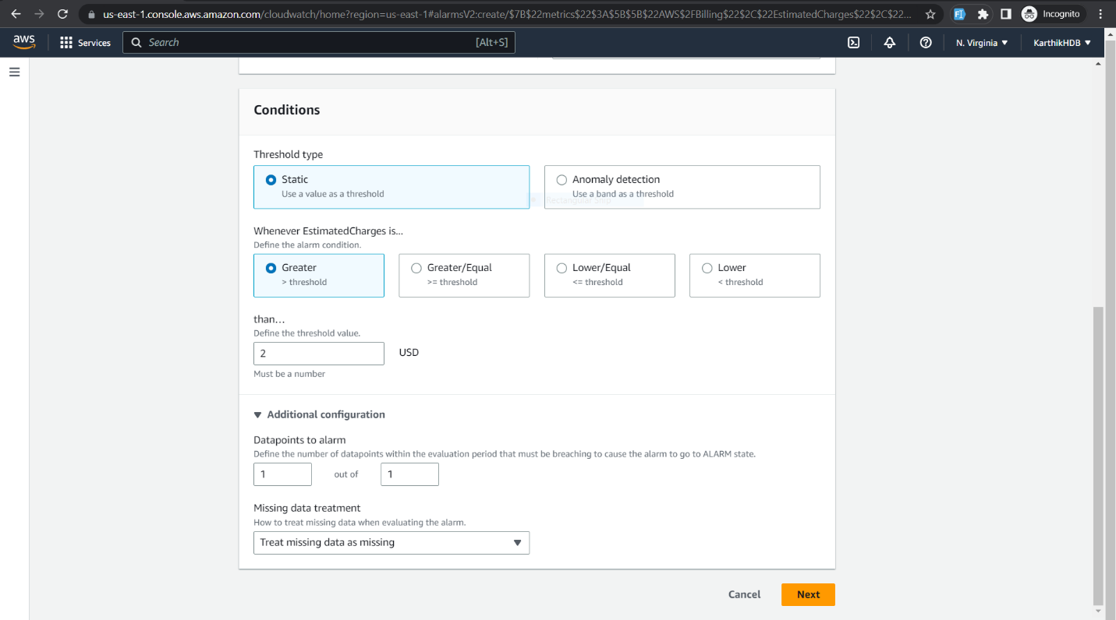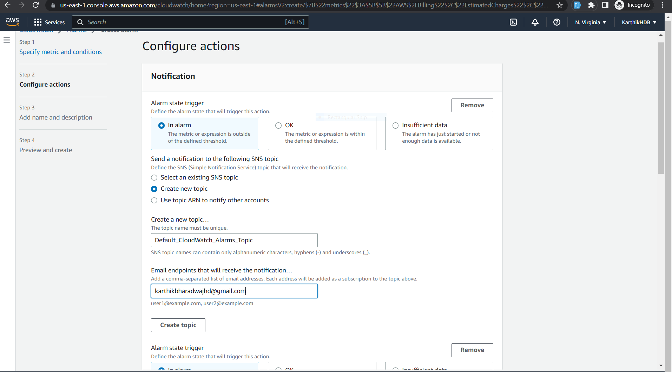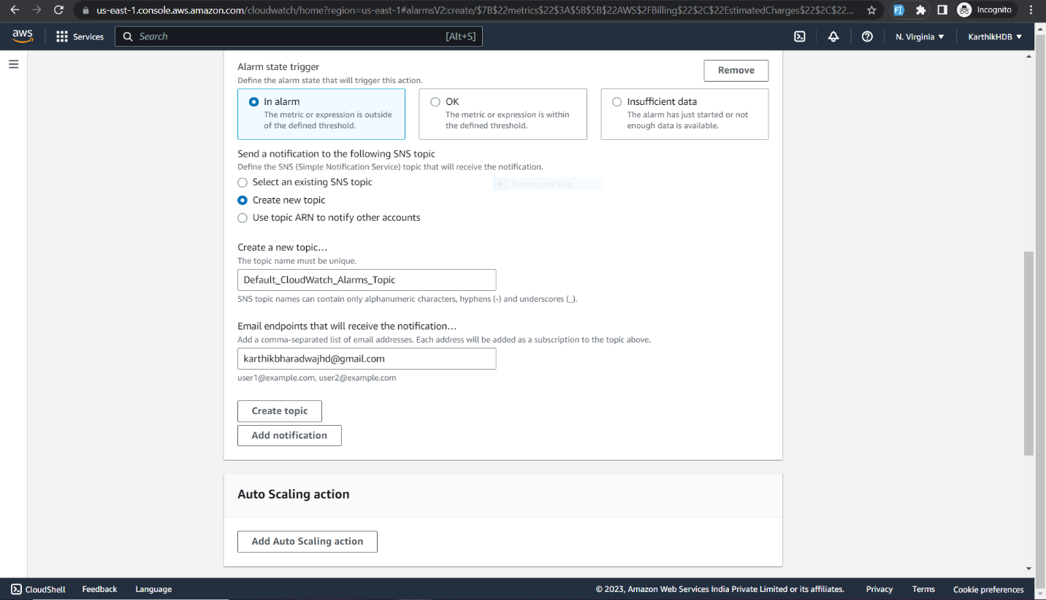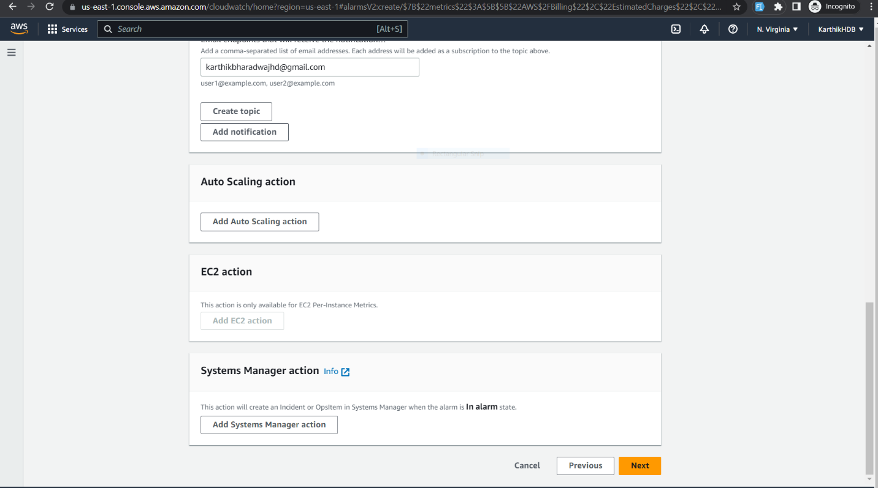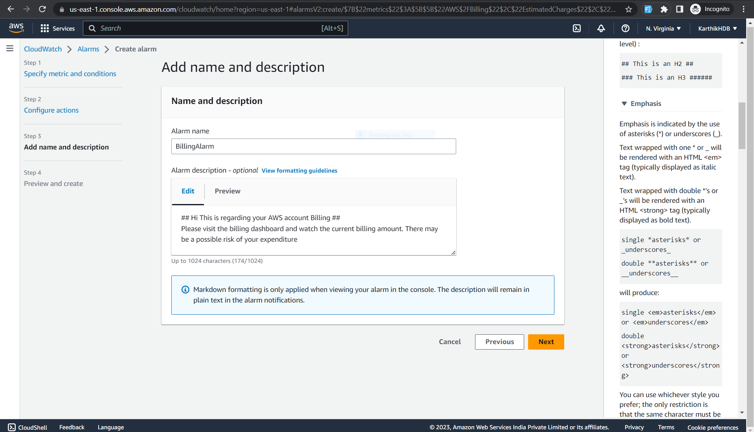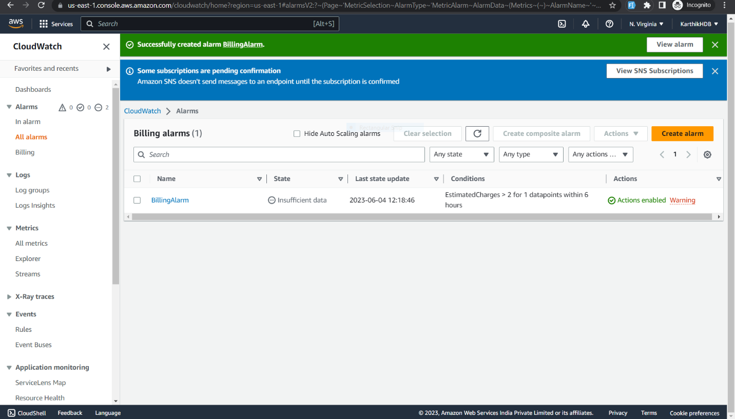

3.Create CloudWatch alarms for S3 buckets: Set up CloudWatch alarms to notify you when S3 buckets reach certain thresholds, such as when the number of objects in a bucket exceeds a certain limit or when the amount of data stored in a bucket reaches a certain size.A screenshot of a computer

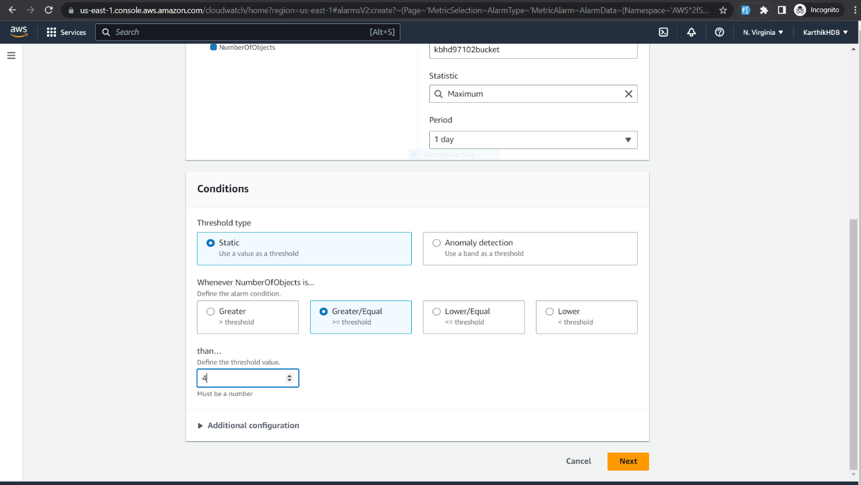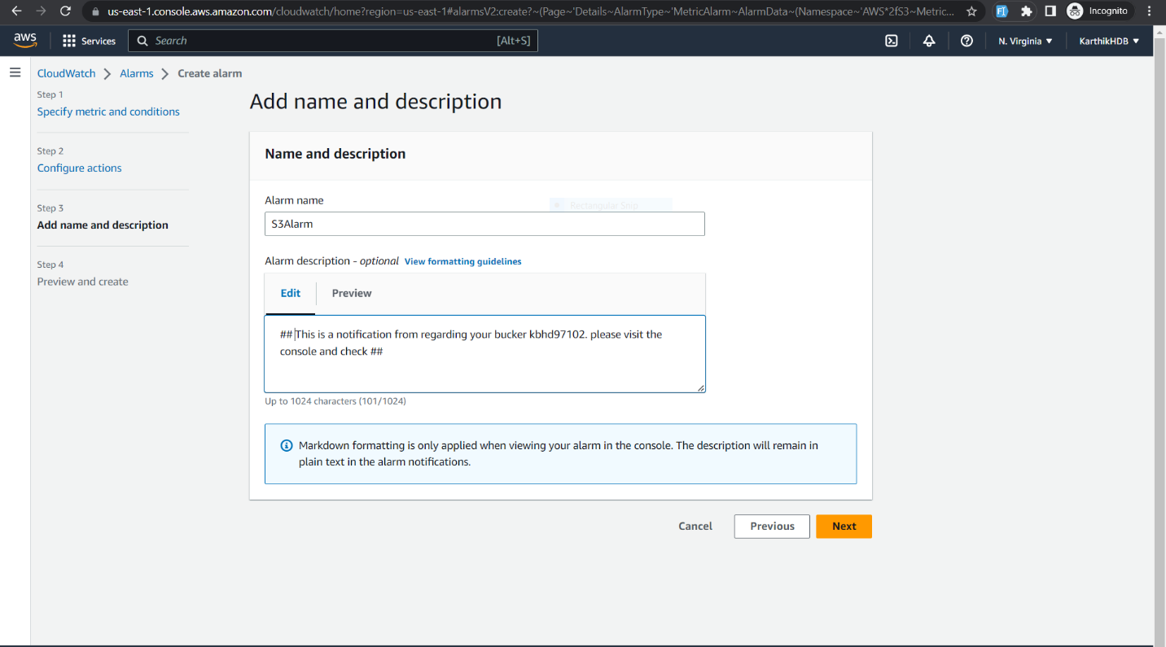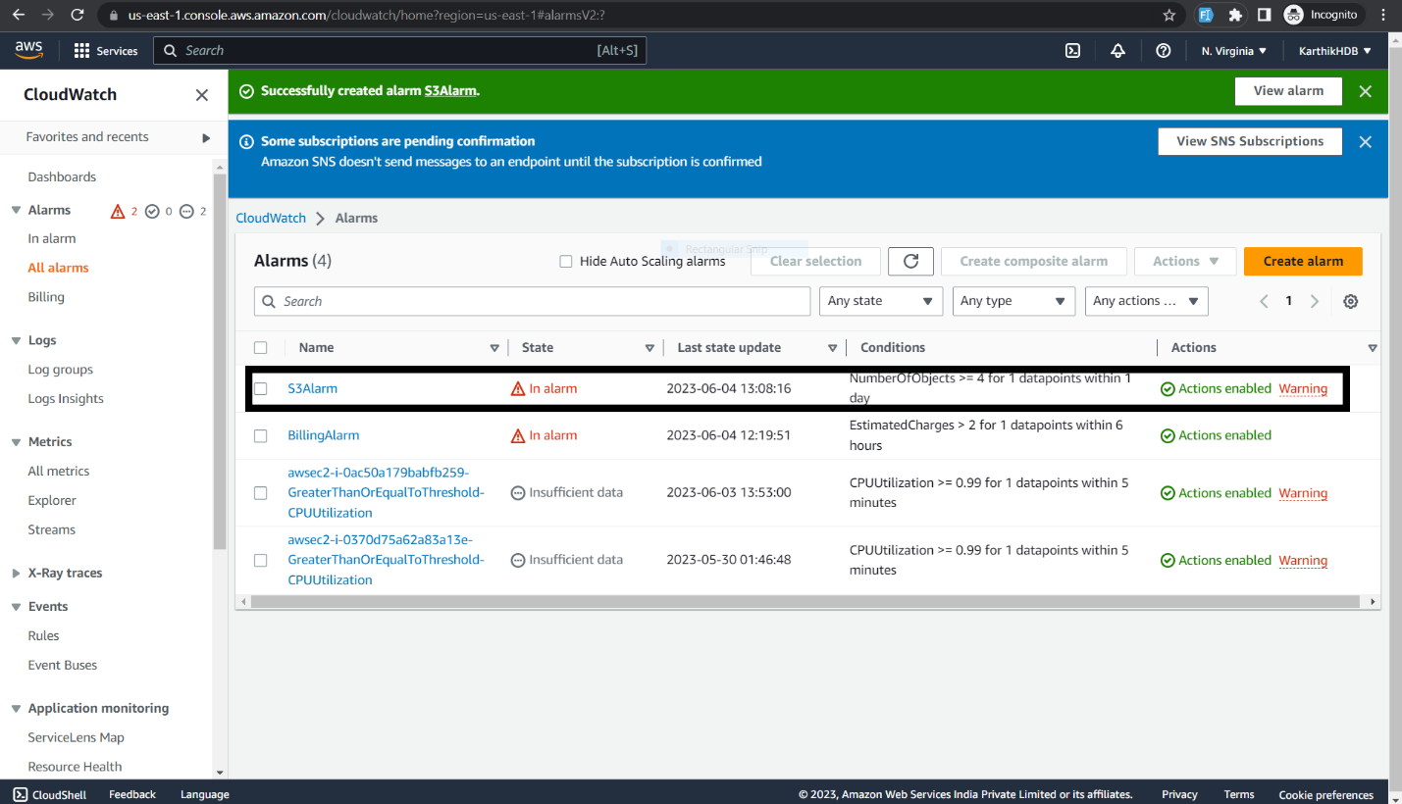

4. Use CloudWatch to monitor EC2 instances: Set up CloudWatch to monitor the performance of your EC2 instances, such as CPU utilization, memory usage, network traffic, and disk I/O.

Create an EC2 instance “SampleImageInordertoCheckCW”

Connect to SSH client and run the following commands to install cloudwatch agent

wget <https://s3.amazonaws.com/amazoncloudwatch-agent/amazon_linux/amd64/latest/amazon-cloudwatch-agent.rpm> //downloading cloudagent package

sudo rpm -U ./amazon-cloudwatch-agent.rpm //running the cloudwatch-agent package

sudo nano /opt/aws/amazon-cloudwatch-agent/etc/amazon-cloudwatch-agent.json //creating json config file and paste the following code

{

"agent": {

"metrics_collection_interval": 60,

"run_as_user": "cwagent"

},

"metrics": {

"append_dimensions": {

"InstanceId": "${aws:InstanceId}"

},

"metrics_collected": {

"mem": {

"measurement": [

"mem_used_percent"

],

"metrics_collection_interval": 60

},

"swap": {

"measurement": [

"swap_used_percent"

],

"metrics_collection_interval": 60

}

}

}

}

sudo /opt/aws/amazon-cloudwatch-agent/bin/amazon-cloudwatch-agent-ctl -a fetch-config -m ec2 -c file:/opt/aws/amazon-cloudwatch-agent/etc/amazon-cloudwatch-agent.json -s //Starting the cloudwatch agent

sudo tail -f /opt/aws/amazon-cloudwatch-agent/logs/amazon-cloudwatch-agent.log

then you will get the following data in cloudwatch console

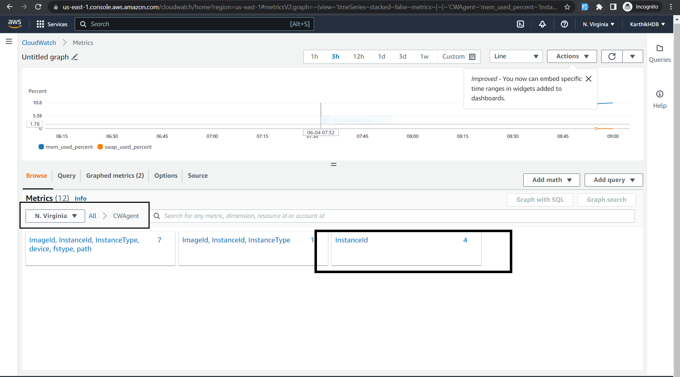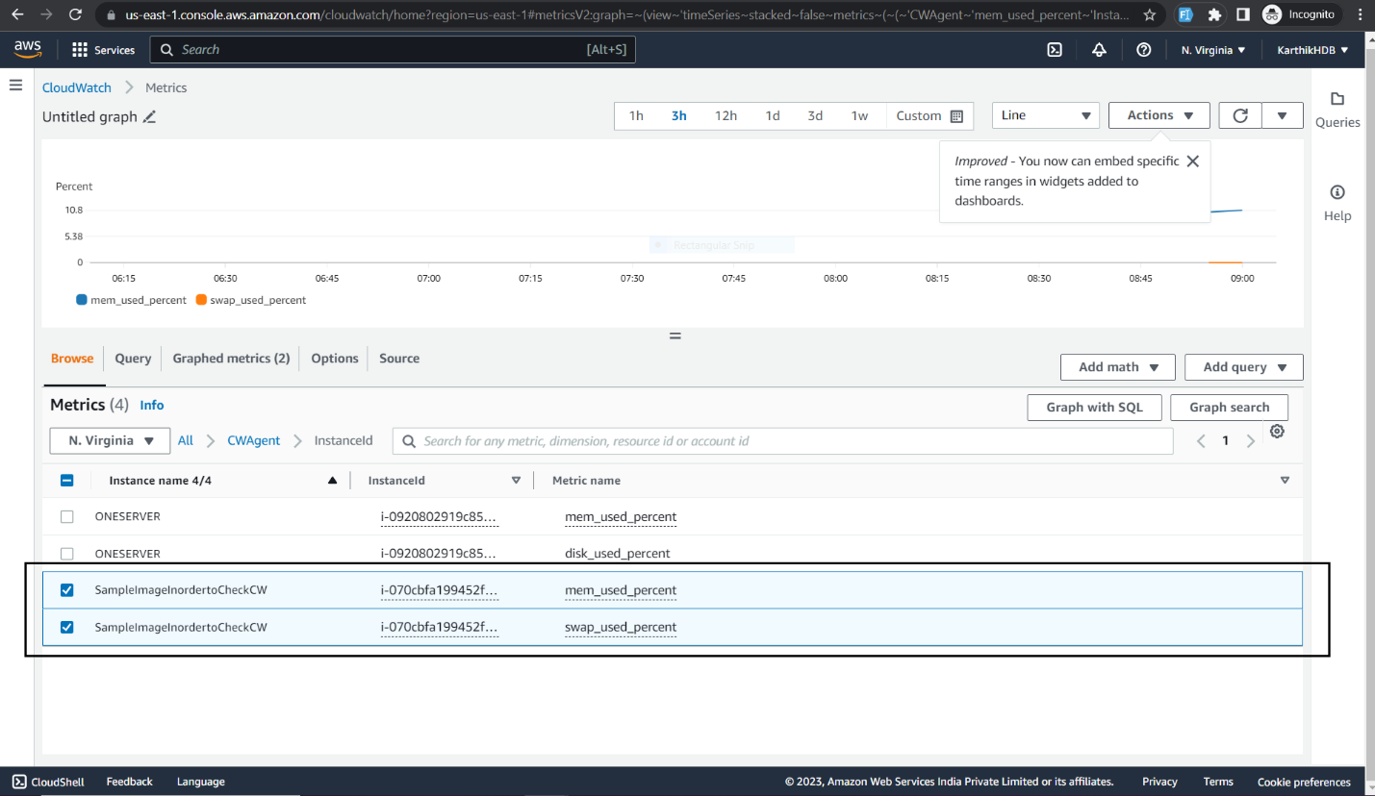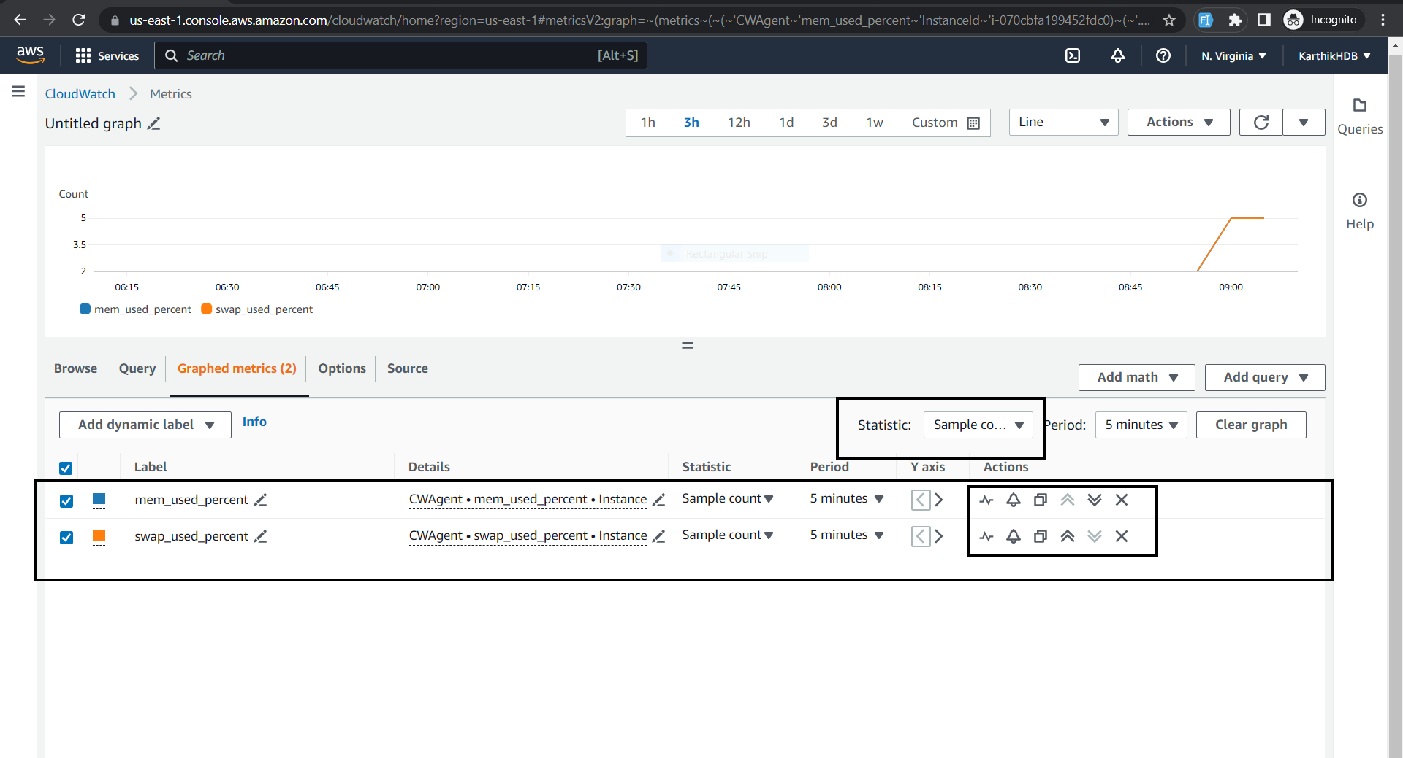

5.Monitor Lambda function performance with CloudWatch: Use CloudWatch to monitor the performance of your Lambda functions, such as memory usage, duration, and error rates.

